### How Ansible Works

* In ansible we specify our desired state (What we want) in **YAML** which is called as Playbook 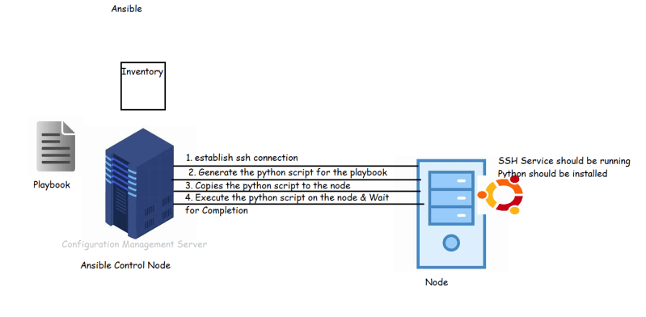

### What’s so great about Ansible

* Easy to Read Syntax
* Nothing to install on Remote Hosts
* Ansible Control Node can scale to manage hundreds of nodes and it is very simple
* Built-in Stuff to do most of the automation

### What Do I Need to Know?

* Connecting to a remote machine using SSH
* Public/Private keys for SSH
* Interact with Linux bash shell
* Install packages
* Basics of working in Linux
  + sudo
  + file & folder permissions
  + set environmental variables
* We use ansible to deploy applications on servers, we should know how to do the deployment and configuration manually.

### Lab Setup:

* We would be using the following Lab setup 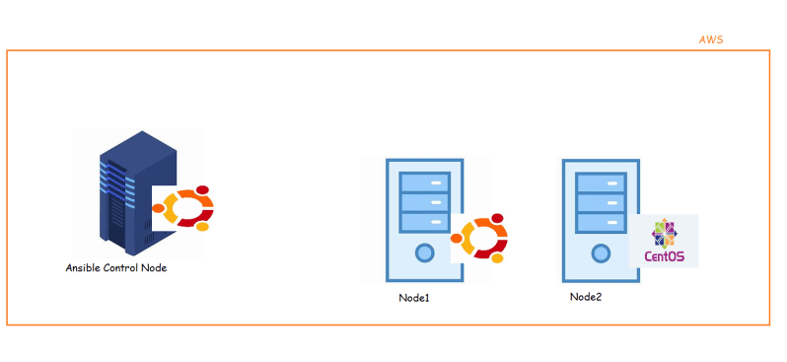
* We need 2 ubuntu 18 virtual machines & one centos 7 VM
* For this lab I will be using AWS Cloud
* Setting up Ansible Control Node
* Execute the following commands

Support link: <https://docs.ansible.com/ansible/latest/installation_guide/intro_installation.html#installing-ansible-on-ubuntu>

sudo apt update

sudo apt install software-properties-common

sudo apt-add-repository --yes --update ppa:ansible/ansible

sudo apt install ansible

ansible --version

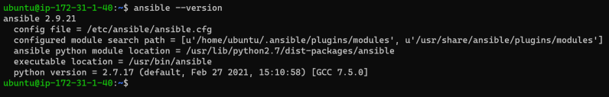

#### Linux Topics

* User management
* sudo
* key management (ssh-keygen, ssh-copy-id)
* package management (apt, yum, dnf)
* file editing (nano, vim)